**Chapter 9 SAVINGS, INVESTMENT & LF QUESTIONS**

**Refer to the following graph to answer the next six questions.**

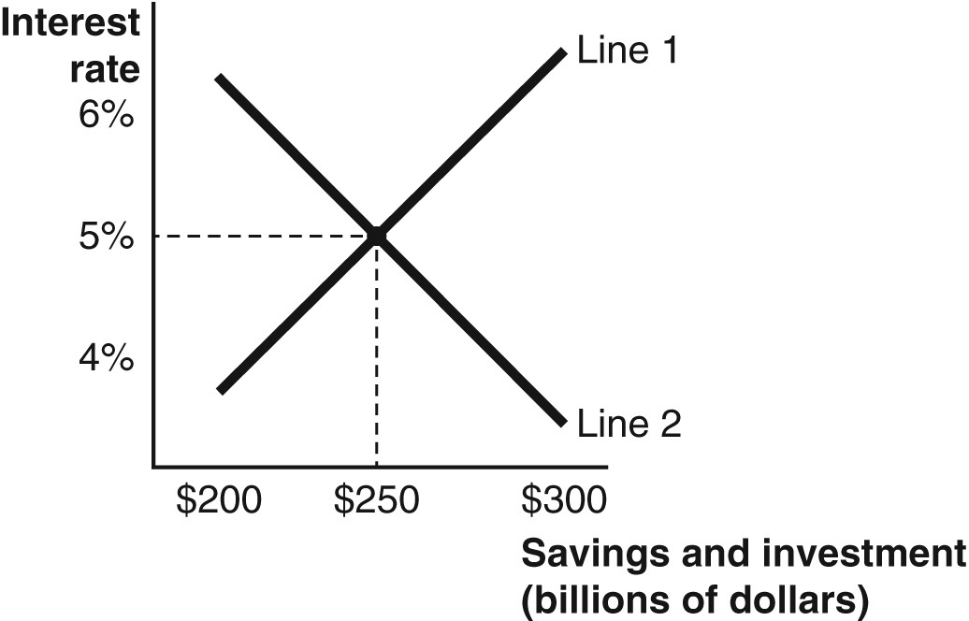

**1. In the graph, Line 1 represents ________, Line 2 represents ________, and 5% represents ________.**

a. savings; the supply of loanable funds; a surplus of loanable funds

b. savings; the demand for loanable funds; the equilibrium interest rate

c. investment; the supply of loanable funds; a shortage of loanable funds

d. investment; the demand for loanable funds; the equilibrium interest rate

e. foreign savings; the supply of loanable funds; a surplus of loanable funds

**2. In the graph, at an interest rate of 4%, the**

a. quantity demanded of loanable funds equals the quantity supplied of loanable funds, and equilibrium is reached.

b. quantity demanded of loanable funds is greater than the quantity supplied of loanable funds, and there is a surplus of loanable funds.

c. demand for loanable funds is greater than the supply of loanable funds, and there is a shortage of loanable funds.

d. quantity demanded of loanable funds is greater than the quantity supplied of loanable funds, and there is a shortage of loanable funds.

e. quantity demanded of loanable funds is less than the quantity supplied of loanable funds, and there is a shortage of loanable funds.

**3. In the graph, at an interest rate of 6%, the**

a. quantity demanded of loanable funds equals the quantity supplied of loanable funds, and equilibrium is reached.

b. quantity demanded of loanable funds is greater than the quantity supplied of loanable funds, and there is a surplus of loanable funds.

c. demand for loanable funds is greater than the supply of loanable funds, and there is a shortage of loanable funds.

d. quantity demanded of loanable funds is greater than the quantity supplied of loanable funds, and there is a shortage of loanable funds.

e. quantity demanded of loanable funds is less than the quantity supplied of loanable funds, and there is a surplus of loanable funds.

**4. In the graph, at an interest rate of 5%, the**

a. quantity demanded of loanable funds equals the quantity supplied of loanable funds, and equilibrium is reached.

b. quantity demanded of loanable funds is greater than the quantity supplied of loanable funds, and there is a surplus of loanable funds.

c. demand for loanable funds is greater than the supply of loanable funds, and there is a shortage of loanable funds.

d. quantity demanded of loanable funds is greater than the quantity supplied of loanable funds, and there is a shortage of loanable funds.

e. quantity demanded of loanable funds is less than the quantity supplied of loanable funds, and there is a surplus of loanable funds.

**5. In the graph, Line 2 represents the ________, and, at an interest rate of 6%, a ________ of loanable funds exists.**

a. supply of loanable funds; shortage

b. quantity demanded of loanable funds; surplus

c. demand for loanable funds; shortage

d. quantity supplied of loanable funds; surplus

e. demand of loanable funds; surplus

**6. What does Line 2 in the graph above tell us?**

a. If the interest rate falls, more funds will be borrowed.

b. If the interest rate falls, more money will be saved.

c. If the interest rate falls, the demand will shift outwards.

d. More money will be borrowed at all interest rates.

e. If the interest rate rises, less money will be saved

**7. The demand for loanable funds is**

a. savings, because households borrow more than firms.

b. horizontal, because firms are infinitely sensitive to interest rates.

c. vertical, because it is nonresponsive to interest rates.

d. upward sloping, because at higher interest rates the opportunity cost of holding money increases.

e. investment, because firms borrow to invest in physical or human capital.

**8. According to the textbook, savers in the loanable funds market tend to be ________ and borrowers tend to be ________.**

a. the government and foreign entities; domestic entities and firms

b. firms and the U.S. government; households and foreign entities

c. foreign firms and households; foreign banks and domestic firms

d. households and foreign entities; firms and the U.S. government

e. insurance companies and households; small firms and microcapital organizations

**9. The timeline of production indicates that**

a. supply creates its own investment.

b. first production occurs, then profit represents a residual, and then this residual is saved.

c. firms first invest (which is borrowing), then they produce, and then the revenue they receive is used to pay workers and lenders.

d. firms first save (which is lending), then they produce, and then the revenue they receive is used to lend even more.

e. real interest rates rise faster than nominal interest rates because production occurs before income is received by the firm.

Refer to the following graph to answer the next 2 questions.  
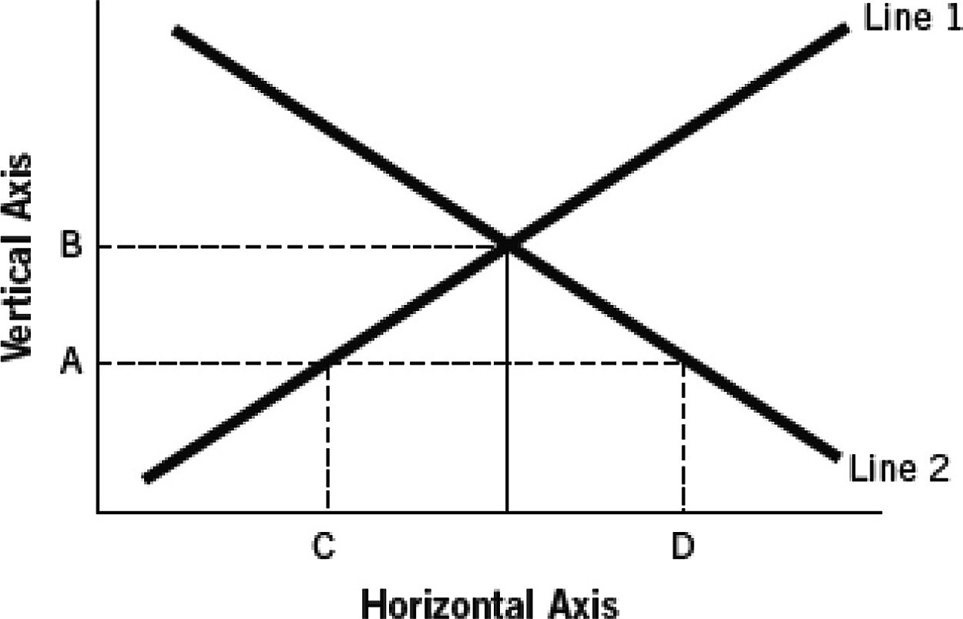

**10. On the graph above, how is a surplus of funds shown?**

a) as the distance between Points C and D

b) as the distance between Points A and B

c) as the distance between Point C and the equilibrium

d) as the distance between Point D and the equilibrium

e) It is not shown.

**11. On the graph above, how is a shortage of funds shown?**

a) as the distance between Points C and D

b) as the distance between Points A and B

c) as the distance between Point C and the equilibrium

d) as the distance between Point D and the equilibrium

e) It is not shown.

**12. The interest rate represents ________ to ________ and ________ to ________.**

a) income; governments; the cost of funds; savers

b) the cost of funds; corporations; a return; firms

c) profit; firms; the marginal rate of arbitrage; foreign entities

d) the cost of borrowing; firms; a reward for saving; households

e) profit; arbitrage companies; loss; financial institutions

**13. You borrow $50,000 today at a rate of 5%. Today, inflation instantly rises to 7% and stays that way for the duration of your loan. Based on the above information today**

a) the real rate of interest on your loan is 2%.

b) the real rate of interest on your loan is 10%.

c) the real rate of interest on your loan is -2%.

d) you will pay the lender back exactly $55,500.

e) you will pay the lender back exactly $60,700.

**14. You borrow $100,000 today at a nominal rate of 3%; inflation for the past 5 years has been exactly 2%. Today, inflation instantly rises to 3% and stays that way for the duration of your loan. Based on the above information, and all else being equal, today**

a) you are worse off because inflation has risen.

b) you are better off strictly because 3% is still more than 2%.

c) you are better off because you are paying back the loan with dollars that represent less purchasing power today than the dollars you borrowed before.

d) the lender is better off because the real rate of interest automatically increases when inflation increases.

e) both you and the lender are worse off because real rates fall when inflation rises.

**15. Why might someone borrowing money be interested in the real interest rate?**

a) because the real interest rate determines how much interest they must pay each month

b) because the real interest rate is the same thing as the real inflation rate

c) because the real interest rate tells the total payment–not just the part of the payment that is interest

d) because the real interest rate tells how much the interest rate is after inflation is taken into account

e) because the real interest rate gives the total amount paid in interest over the total term of the loan

**16. Assume real interest rates fall from 3% to 1%. What could cause this, all other things being equal?**

a) a 3% increase in inflation

b) a 1% decrease in inflation

c) a 2% increase in nominal interest rates

d) a 2% decrease in nominal interest rates

e) a 1% decrease in real interest rates

**17. If inflation is occurring, then**

a) both real and nominal interest rates are greater than zero.

b) both real and nominal interest rates are less than zero.

c) the nominal interest rate exceeds the real interest rate.

d) the real rate of interest exceeds the nominal rate of interest.

e) preferences in the nation have fallen.

**18. If deflation is occurring, then**

a) both real and nominal interest rates are above zero.

b) both real and nominal interest rates are below zero.

c) the nominal interest rate exceeds the real interest rate.

d) the real rate of interest exceeds the nominal rate of interest.

e) time preferences in the nation have fallen.

**19. Wealth increases in the United States because the value of the stock market increases; if all else is equal, these increases would cause**

a) a smaller gap between the real and nominal rates of interest.

b) the demand for loanable funds to decrease.

c) the supply of loanable funds to increase.

d) the supply of loanable funds to decrease.

e) inflation to increase

**20. If foreign income and wealth increase, these increases would most likely**

a) not affect interest rates.

b) cause the supply of loanable funds to increase.

c) cause the supply of loanable funds to decrease.

d) cause inflation to decrease.

e) cause the demand for loanable funds to decrease.

Use the following graph (shifts in the supply of loanable funds) for the next 3 questions.

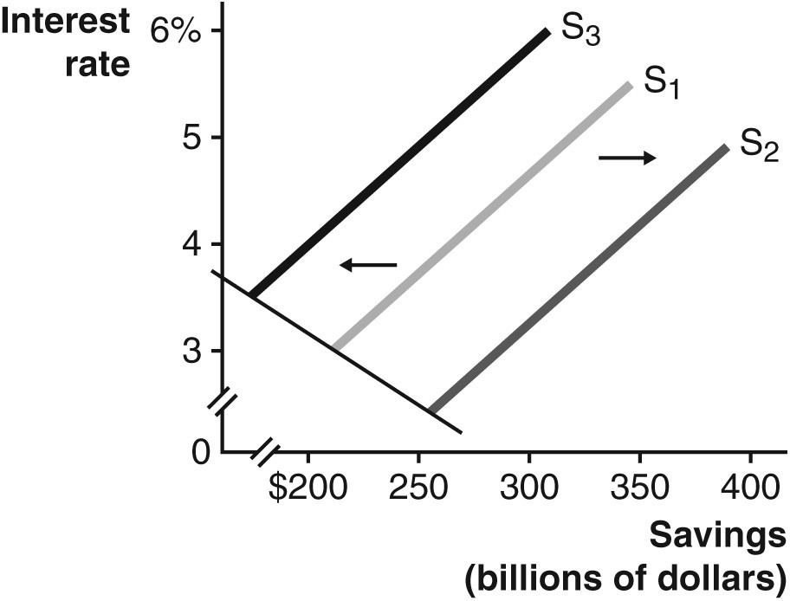

**21. Assuming the supply of loanable funds is at S1, which of the following represents an increase in the number of retired people in a nation?**

a) a shift to S2

b) a shift to S3

c) no change

d) a movement up and to the right along S1

e) a movement down and to the left along S1

**22. Assuming the supply of loanable funds is at S1, which of the following represents an increase in the number of people entering their high-earning years?**

a) a shift to S2

b) a shift to S3

c) no change

d) a movement up and to the right along S1

e) a movement down and to the left along S1

**23. Assuming the supply of loanable funds is at S1, which of the following represents an increase in time preferences of people in a nation?**

a) a shift to S2

b) a shift to S3

c) no change

d) a movement up and to the right along S1

e) a movement down and to the left along S1

**24. Assume an epidemic hits a nation hard. As a result, people now have lower life expectancies. The most likely result would be**

a) a higher supply of loanable funds.

b) a higher demand for loanable funds.

c) a lower supply of loanable funds.

d) higher productivity of capital.

e) a decrease in equilibrium interest rates.

**25. If life expectancy rises because people begin to eat food containing fewer preservatives and chemicals, we would expect**

a) time preference to fall and savings to increase.

b) time preference to rise and savings to increase.

c) time preference to fall and savings to decrease.

d) time preference to rise and savings to decrease.

e) interest rates to fall to zero.

**26. Kerishma is saving money for a soccer ball but is tempted to buy a book. If Kerishma buys a book rather than continuing to save for the ball,**

a) she has exchanged a high time preference for a low time preference.

b) she has exchanged a low time preference for a high time preference.

c) she has engaged in consumption smoothing.

d) the bookseller has moved from being a lender of loanable funds to a borrower.

e) the bookseller has moved from being a borrower to a lender of loanable funds.

**27. Because most people have a time preference, they**

a) must earn interest to consume now (save later) and are willing to forego interest to consume later (save now).

b) must be paid interest to consume later (save now) and are willing to forego interest to consume now (save later).

c) are willing to accept simple interest in the short run but only compound interest in the long run.

d) will accept positive rates of interest on checking accounts and negative rates of interest on savings accounts.

e) prefer more free time to less free time.

**28. If the U.S. economy experiences a major recession, then**

a) the demand for loanable funds will shift right.

b) the supply of loanable funds will shift right.

c) the demand for loanable funds will shift left.

d) the supply of loanable funds will shift left.

e) both the supply and demand for loanable funds will increase.

**29. One could correctly argue that lower capital productivity would**

a) increase the value of capital and the supply of loanable funds.

b) reduce the value of capital and the supply of loanable funds.

c) only affect interest rates in the long run.

d) increase the value of capital and the demand for loanable funds.

e) reduce the value of capital and the demand for loanable funds.

**30. Assume the market for loanable funds is in equilibrium at 5% interest. Assuming that firms become more pessimistic about future profits, all else being equal,**

a) the equilibrium interest rate would rise and the equilibrium quantity would fall.

b) both the equilibrium interest rate and the equilibrium quantity would rise.

c) both the equilibrium interest rate and the equilibrium quantity would fall.

d) the equilibrium interest rate would fall and the equilibrium quantity would rise.

e) the equilibrium real rate of interest would become negative and the equilibrium quantity would remain unchanged.

**31. If everyone began feeling better about their economic future, "animal spirits" would become**

a) negative.

b) more positive and firms would invest more, causing the demand for loanable funds to increase.

c) more positive and firms would invest more, causing the supply of loanable funds to increase.

d) more positive and firms would invest more, causing the supply of loanable funds to decrease.

e) more positive and firms would invest more, causing the demand for loanable funds to decrease.

Use the following graph (shifts in the demand for loanable funds) for the next 2 questions.

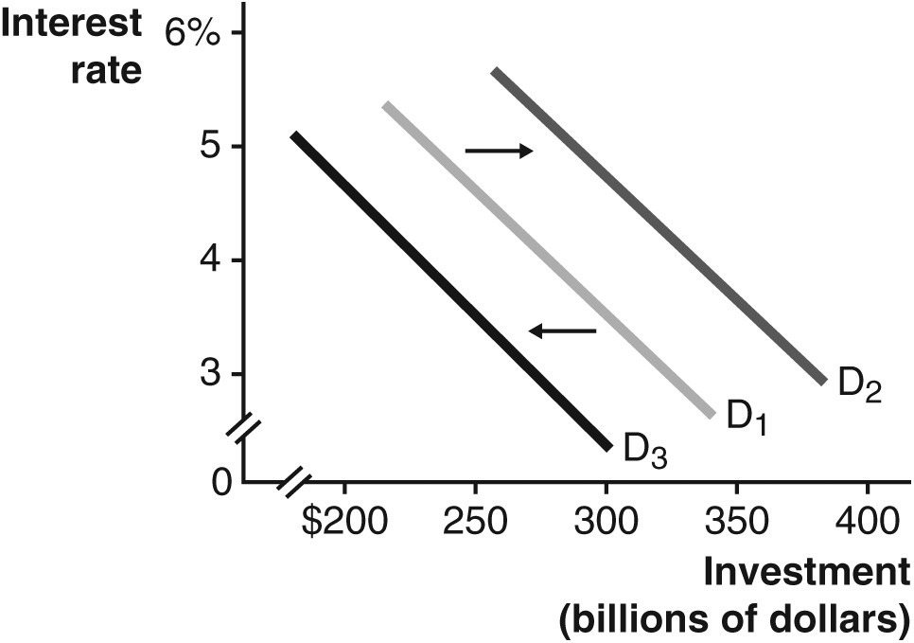

**32. Assuming the demand of loanable funds is at D1, which of the following represents a decrease in investor confidence?**

a) a shift to D2

b) a shift to D3

c) no shift or movement change

d) a movement up and to the left along D1

e) a movement down and to the right along D1

**33. Assuming the demand of loanable funds is at D1, which of the following represents an increase in the productivity of capital?**

a) a shift to D2

b) a shift to D3

c) no shift or movement change

d) a movement up and to the left along D1

e) a movement down and to the right along D1

**34. Assume the demand for loanable funds decreases while the supply of loanable funds does not change. The result of this would be that**

a) the equilibrium quantity of loanable funds decreases and the equilibrium interest rate increases.

b) the equilibrium quantity of loanable funds increases and the equilibrium interest rate decreases.

c) both the equilibrium quantity of loanable funds and the equilibrium interest rate decrease.

d) the equilibrium interest rate decreases, but the equilibrium quantity of loanable funds remains unchanged.

e) the equilibrium interest rate increases, but the equilibrium quantity of loanable funds remains unchanged.

**35. Assume the supply of loanable funds decreases while the demand for loanable funds remains constant. This would cause**

a) the equilibrium quantity of loanable funds to decrease and the equilibrium interest rate to increase.

b) the equilibrium quantity of loanable funds to increase and the equilibrium interest rate to decrease.

c) both the equilibrium quantity of loanable funds and the equilibrium interest rate to increase.

d) the equilibrium interest rate to increase, leading to a new lower equilibrium quantity.

e) the equilibrium interest rate to increase, but the equilibrium quantity of loanable funds would remain unchanged.

**36. Which is a correct version of the Fisher equation?**

a) real interest rate = nominal interest rate + inflation rate

b) nominal interest rate = real interest rate + inflation rate

c) real interest rate = inflation rate – nominal interest rate

d) real interest rate – nominal interest rate = inflation rate

e) nominal interest rate + real interest rate = inflation rate

**37. Which event could be expected to shift a nation’s supply of loanable funds, as shown?**

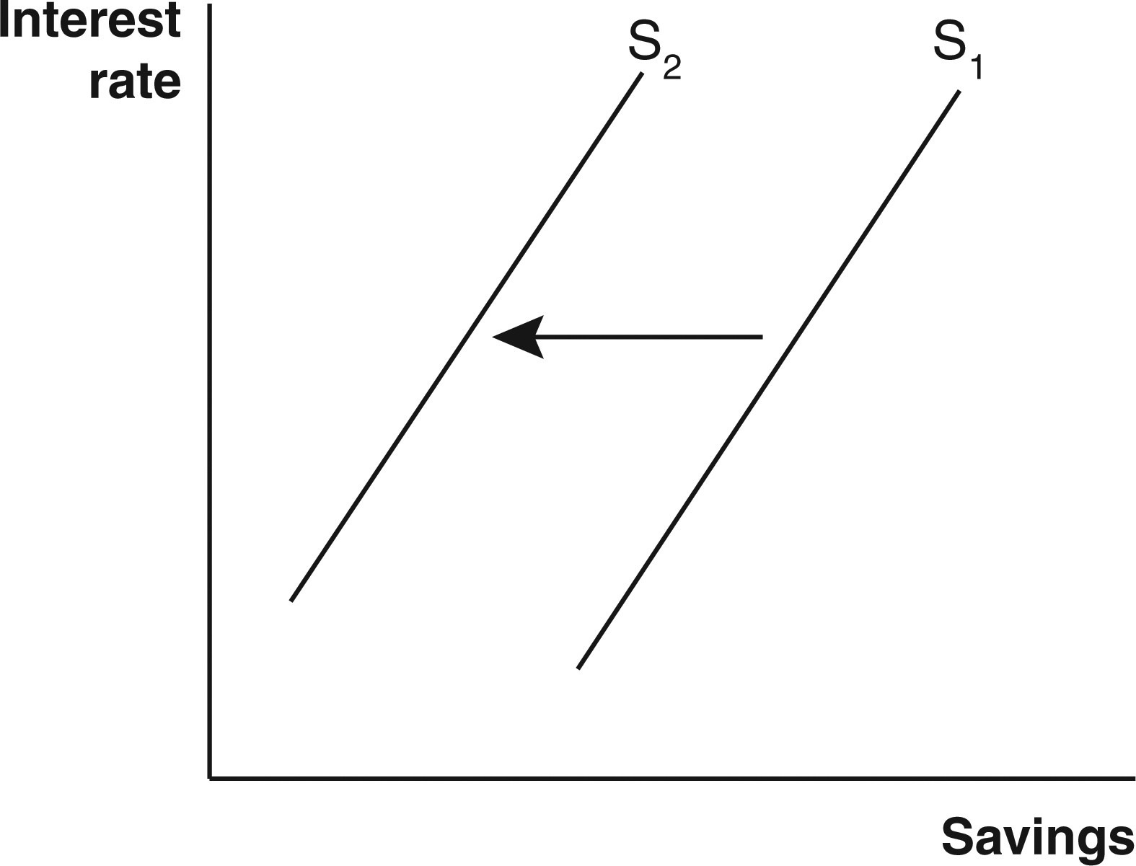

a) increased purchases of domestic stocks by foreign investors

b) an increase in time preference

c) a culture-wide revival of the virtue of patience

d) greater numbers of people choosing to keep working when they could retire

e) a wave of working adults entering their peak-earnings years

**38. Why does the demand curve for loanable funds slope downward from left to right?**

a) Interest rates on loanable funds typically decline over time.

b) The interest rate on a loan is directly proportional to demand.

c) The lower a loan’s interest rate, the more firms want the loan.

d) Demand for loanable funds decreases more often than it increases.

e) The greater the demand for loanable funds, the more the curve shifts.

**Refer to the following graph that describes income and consumption patterns over a typical life cycle to answer the next 3 questions.**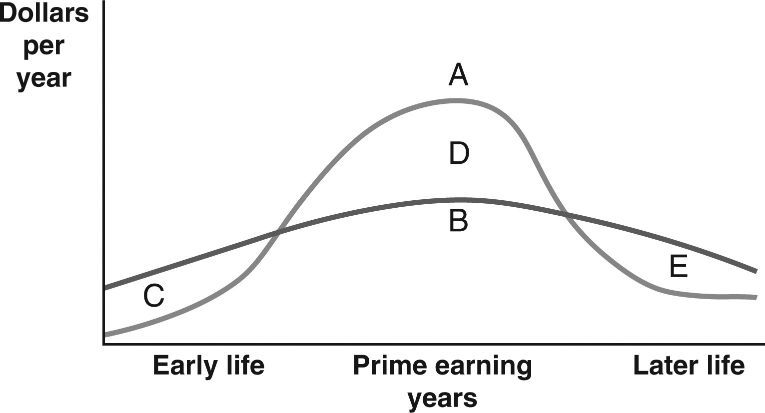

**39. Which part of the accompanying graph depicts borrowing?**

a) Curve A

b) Curve B

c) Region C

d) Region D

e) Region E

**40. Which part of the accompanying graph depicts saving?**

a) Curve A

b) Curve B

c) Region C

d) Region D

e) Region E

**41. Which part of the accompanying graph depicts dissaving?**

a) Curve A

b) Curve B

c) Region C

d) Region D

e) Region E

**42. What would be an example of increased productivity of physical capital?**

a) A potter’s workshop starts paying for itself when the potter begins to sell finished pieces.

b) A new piece of architectural software gets more use as workers gradually get familiar with it.

c) A forklift moves more pieces per hour when there is a more experienced operator at the wheel.

d) A new automated lathe performs the same jobs faster than the older model did.

e) A commercial truck uses less diesel fuel after a tune-up than it did before.

**43. Which factor may be expected to decrease the supply of loanable funds in the United States over the next decade?**

a) a slowed rate of technological innovation

b) a decline in investor confidence

c) a leveling off of the trend of rising home values

d) a wave of retirement of active workers

**44. Interest is the reward for saving.” Or, alternatively, “interest is the opportunity cost of consumption.” Explain how these two statements are equivalent.**

**45. “Firms borrow to fund an investment if, and only if, the expected return on the investment is greater than the interest rate on the loan.” Explain this statement.**

**46. How do rising incomes and wealth, whether domestically or abroad, boost a nation’s supply of loanable funds?**

**47. Explain how consumption smoothing involves the loanable funds market.**

**48. How does the choice either to go to college or high school straight into the labor force illustrate the phenomenon of varying time preferences?**

**49. Explain why the wave of retiring baby boomers may lead to firms paying higher interest rates for loans.**

**50. Explain why, although both young adults and the elderly typically spend more than they earn, it makes sense that young people would engage in borrowing while the elderly would engage in dissaving.**

**51. Why is it likely that, in the next 10 to 15 years, there will be a decrease in the supply of loanable funds?**